CloverDev (TCPHC)

(2022)

Reference Book

Contents

1. Theme 1

2. SEO 1

3. Marketing, Site Analysis 2

4. Site Loading Speed 4

5. Security 4

6. Environment 4

7. Performance, Maintenance 5

8. Business 6

9. Cumstomer Management 7

10. Chatting 8

11. Work TimeZone 9

12. Third Party API 9

13. Laravel packages 21

14. Reference URL 23

15. Reference Tool 27

# Theme

* Favicon

A favicon is a graphic image (icon) associated with a particular Web page and/or Web site. Many recent user agents (such as graphical browsers and newsreaders) display them as a visual reminder of the Web site identity in the address bar or in tabs.



* Favicon Genertor

<https://realfavicongenerator.net/>

* Font, Main Color (2 or 3 colors)

# SEO

* Social Media Meta tag

e.g.

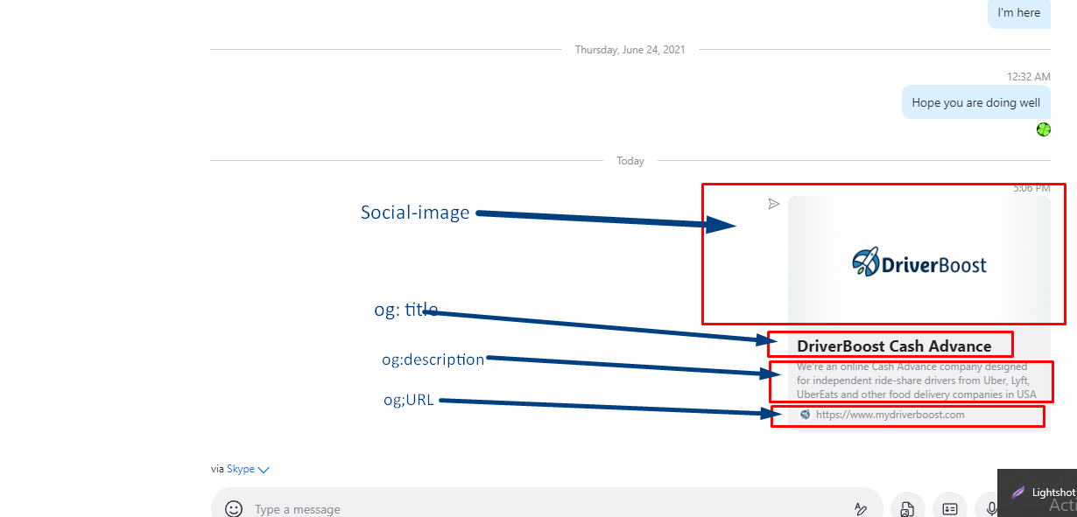

<meta property="og:image" content="{{ asset('assets/images/DriverBoost_Social_Media_Share.png')}}" />

<meta property="og:type" content="website" />

<meta property="og:url" content="https://www.mydriverboost.com.com/" />

<meta property="og:title" content="DriverBoost Cash Advance" />

<meta property="og:description" content="We're an online Cash Advance company designed for independent ride-share drivers from Uber, Lyft, UberEats and other food delivery companies in USA" />

<https://www.kontentino.com/blog/social-media-meta-tags-a-complete-guide/>

* Meta tag for site SEO

e.g

<title>Buyer Member's FAQ</title>

<meta name="description" content="Merchant Cash Advance investment Frequently Asked Questions - Buyer Members Frequently Asked Questions">

<meta name="author" content="Disruptive MCA">

# Marketing, Site Analysis

* Robot.txt
* Sitemap.xml
* Google Tag Manager

e.g.

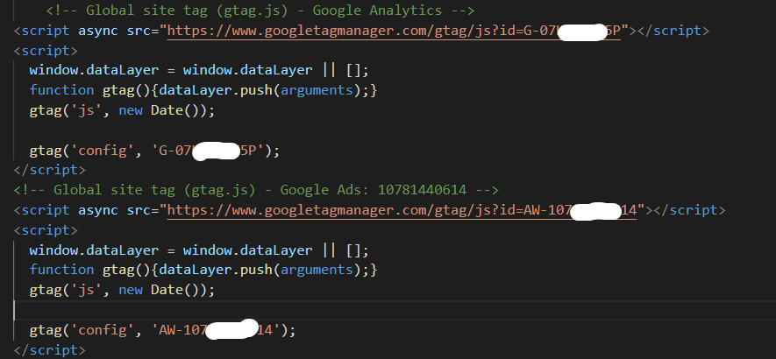

* Facebook

e.g.

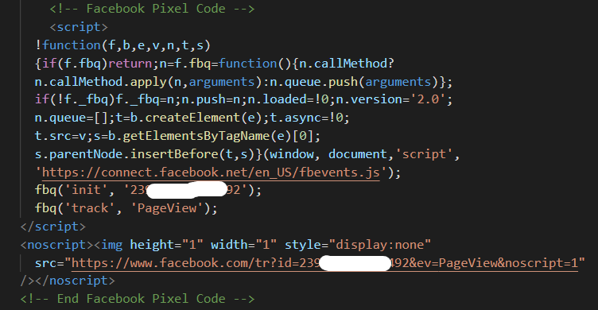

* Etc...
* User-friendly error messages
* Error Display

For security reasons, the correct error should not be displayed.

e.g.

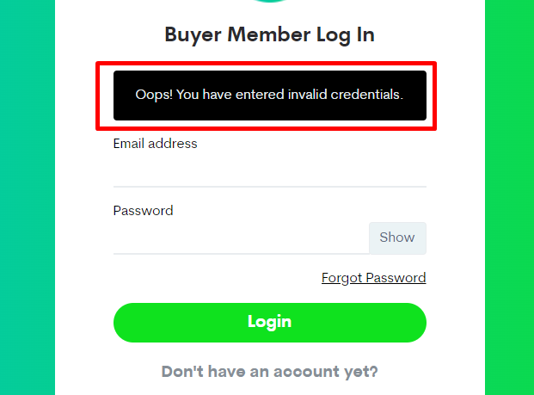

# Site Loading Speed

* Lazy Loading
* Page loading speed tool

e.g.

https://pagespeed.web.dev/

# Security

* Captcha for Bot Check

Google recaptcha, Yandex Captcha etc...

* Login Attempt Limit (3 times)
* Validation check for Fields
* Validation check from frontend
* Validation check from backend
* CSRF token

Cross-Site Request Forgery (CSRF) is **an attack that forces authenticated users to submit a request to a Web application against which they are currently authenticated**. CSRF attacks exploit the trust a Web application has in an authenticated user.

* JWT

JWT, or JSON Web Token, is **an open standard used to share security information between two parties — a client and a server**. Each JWT contains encoded JSON objects, including a set of claims. JWTs are signed using a cryptographic algorithm to ensure that the claims cannot be altered after the token is issued.

* Two-Step-Verification

Two-step verification is **a process that involves two authentication methods performed one after the other to verify that someone or something requesting access is who or what they are declared to be**.

* Agent

A user agent is a “string” – that is, a line of text – identifying the browser and operating system to the web server.

You can check environment of user’s side.

# Environment

* .htaccess file

. htaccess files (or "distributed configuration files") **provide a way to make configuration changes on a per-directory basis**. A file, containing one or more configuration directives, is placed in a particular document directory, and the directives apply to that directory, and all subdirectories thereof.

* Redirect to HTTPS
* Redirect to WWW
* Redirect to Maintenance Page

e.g.

<IfModule mod_rewrite.c>

      RewriteEngine On

        RewriteCond %{HTTPS} off

        # First rewrite to HTTPS:

        # Don't put www. here. If it is already there it will be included, if not

        # the subsequent rule will catch it.

        RewriteRule .* https://%{HTTP_HOST}%{REQUEST_URI} [L,R=301]

        # Now, rewrite any request to the wrong domain to use www.

        # [NC] is a case-insensitive match

        RewriteCond %{HTTP_HOST} !^www\. [NC]

        RewriteRule .* https://www.%{HTTP_HOST}%{REQUEST_URI} [L,R=301]

        #Laravel Redirect to Public folder

        RewriteCond %{REQUEST_URI} !public/

        RewriteRule (.*) /public/$1 [L]

        #maintain mode

        #RewriteCond %{REQUEST_URI} !index.html

        #RewriteRule .* /maintain/index.html [L]

</IfModule>

* .env file

The live site's **environment** must be in **production** mode.

No local or testing.

**Debug** mode must be **false**.

# Performance, Maintenance

* Log

All activity on the site must be logged, even if not in error.

e.g.

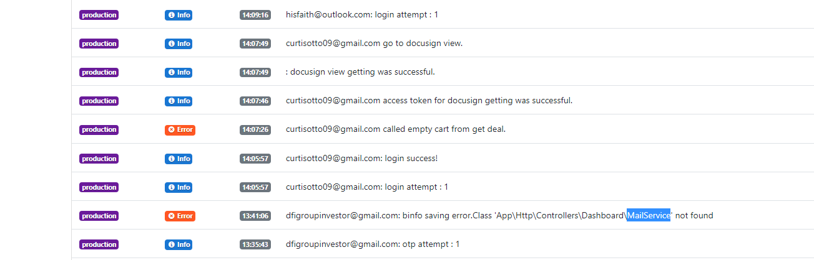

For laravel:

<https://github.com/ARCANEDEV/LogViewer>

* Exception Management

Try Catch

e.g.

try {

     $mservice->send('emails.accept', $details, $receiver);

} catch (\Throwable $e) {

    Log::error($user->email." Application Accepted email sending error: ".$e->getMessage());

}

* Maintenance Mode

# Business

* Debit card / Credit Card
* Debit Card

A debit card is a payment card that can be used in place of cash to make purchases. It is similar to a credit card, but unlike a credit card, the money for the purchase must be in the cardholder's bank account at the time of a purchase and is immediately transferred directly from that account to the merchant's account to pay for the purchase.

* Credit Card

A credit card is a payment card issued to users to enable the cardholder to pay a merchant for goods and services based on the cardholder's accrued debt. The card issuer creates a revolving account and grants a line of credit to the cardholder, from which the cardholder can borrow money for payment to a merchant or as a cash advance.

* Bank account
* Account Type (Saving / Checking)

A **savings** account is an interest-bearing deposit account held at a bank or other financial institution. Though these accounts typically pay a modest interest rate, their safety and reliability make them a great option for parking cash you want available for short-term needs.

A **checking** account is a deposit account held at a financial institution that allows withdrawals and deposits. Also called demand accounts or transactional accounts, checking accounts are very liquid and can be accessed using checks, automated teller machines, and electronic debits, among other methods. A checking account differs from other bank accounts in that it often allows for numerous withdrawals and unlimited deposits, whereas savings accounts sometimes limit both.

* Routing

Routing numbers are nine-digit numbers that identify your bank or credit union in a financial transaction.

* Account Number

Finally, your bank account number is a unique series of numbers that identifies your account. Typically, account numbers range between eight to twelve digits.

# Cumstomer Management

* You need to make Business Name (User Name).

This is different Full Name(firstname, lastname);

You have to contact with client by Business Name.

e.g. lightmoon, Topdev, TrustFreelancer, etc...

* you need to keep moral in the chatting.
* You must keep the promised time with Customer.
* You must continue to work during business hours.
* You need to demonstrate overtime to the customer.
* Greetings are important.

“Have a good dream” than “See you tomorrow”

“How was your weekend?” than “How are you?”

* Holiday management is important.

Message, Card

* Chatting
* Good

Let me think, Let me try, I think ...

* Bad

I can do... , I will...

* Use emoticons carefully in chat.
* You need to set up multiple contact methods with your client.

e.g. email, skype, telegram

* You need to suggest good idea for project.

For it, you have to understand about client business.

* Monday and Sunday is important.
* A day is 8 hours for a customer but 24 hours for you.
* You must inform your customers in advance of any sudden events (like network offline or power off).
* Please keep comment style in the code.

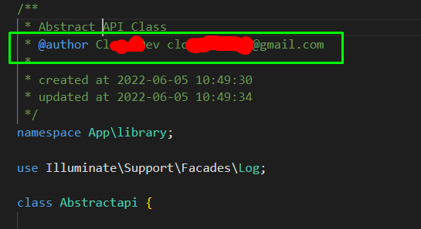

If you are working with agency, you can get client by this comment.

# Chatting

* Introduce

- Greeting

- Skill

- Experience with past jobs

A description of the skills the client wants is important.

You can suggest good idea or API for project.

- Work time and Hourly Rate

e.g.

Hourly rate $30/hr, 40hr/week (Monday - Friday)

I prefer long term work over short term.

We can discuss hourly rates for long term relationship.

If your work is urgent, I can work even on weekends.

(or you can suggest free work to client for weekend.)

- Greeting

Even if you got a bad impression on your clients, you need to leave a good impression on them.

e.g.

If you need my help, you can contact me at any time.

# Work TimeZone

* US

Business time (contact time): 23 - 7 o’clock

Rest Time : 8 – 12 o’clock, 20 – 23 o’clock

Working Time: 14 – 19 o’clock

* Europe

Business time (contact time): 17 - 2 o’clock

Rest Time : 3 – 7 o’clock, 14 – 16 o’clock

Working Time: 8 – 12 o’clock

* All

2 hours rest after meals.

# Third Party API

* **SMS**
* Sakari (<https://sakari.io/>)
* Clicksend (<https://www.clicksend.com/us/>)
* **Signature** (<https://www.docusign.com/>)

<https://github.com/docusign/docusign-esign-php-client>

Developers must create a developer account.

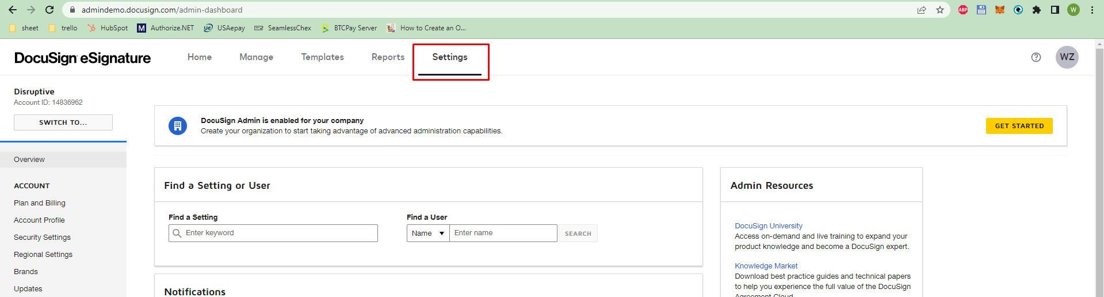

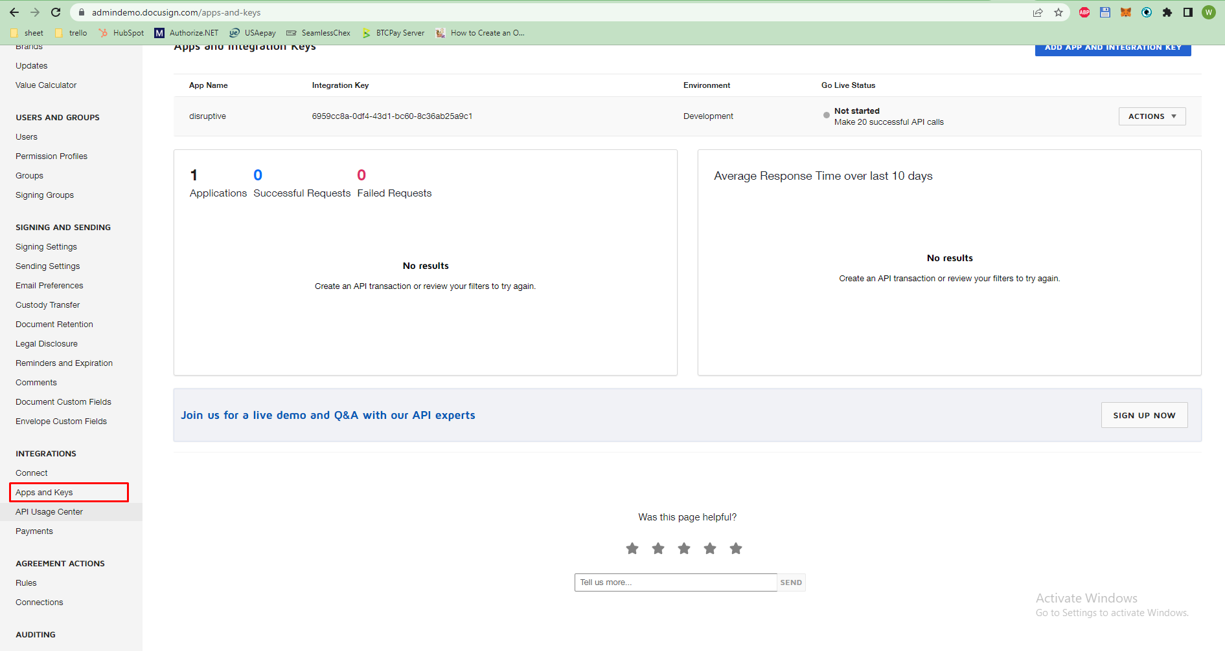

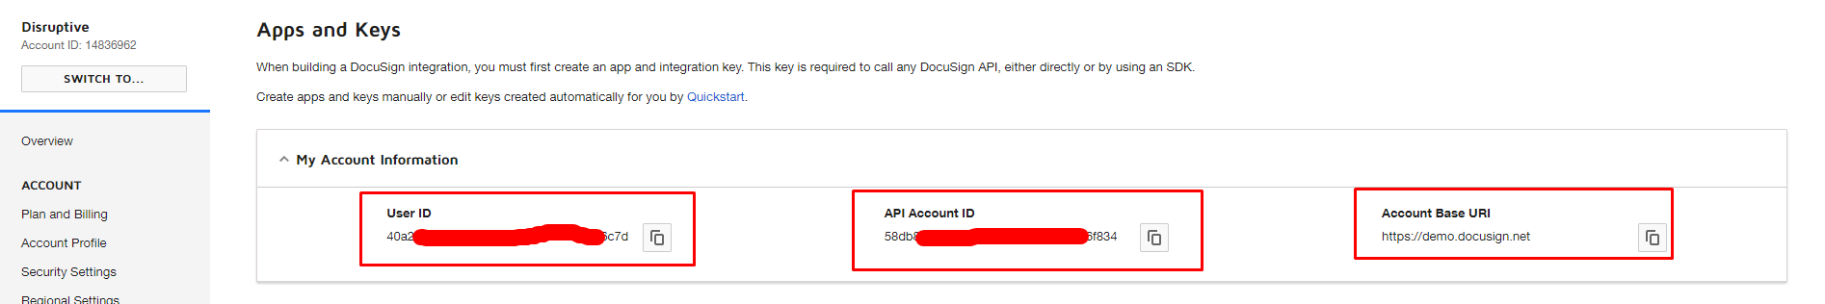

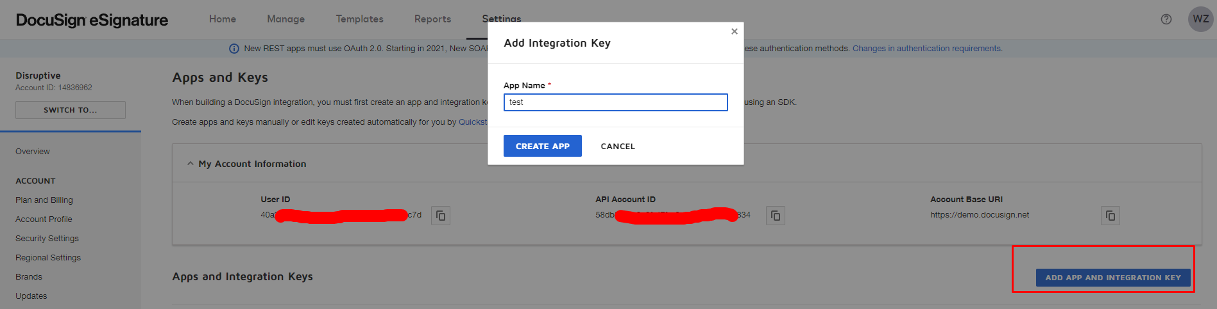

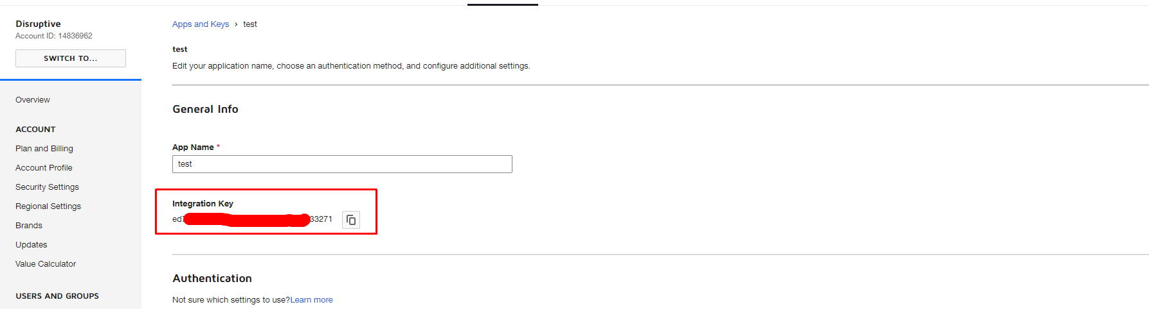

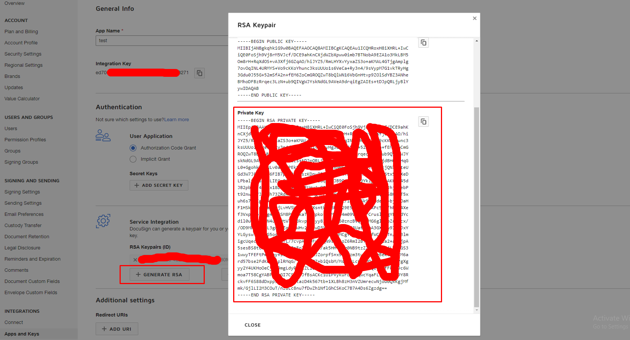

You have to make 20 successful API calls.

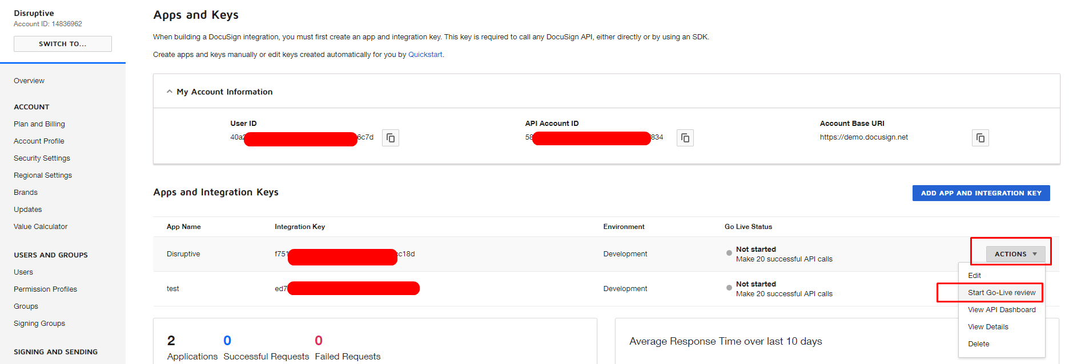

You can connect integrate key to live account after review.

* **Location**
* Geolocation (<https://ipgeolocation.io/>)
* Abstract API (https://www.abstractapi.com/)
* **Payment**
* Card Payment

1. Authorize (<https://www.authorize.net/>)

American Express: 370000000000002

Discover: 6011000000000012

JCB: 3088000000000017

Diners Club/ Carte Blanche: 38000000000006

Visa: 4007000000027

4012888818888

4111111111111111

Mastercard: 5424000000000015

2223000010309703

2223000010309711

* ACH payment

1. Seamless Chex()

https:// seamlesschex.com/

Customer will create account for seamless chex.

Sandbox and Production will use same credential.

*sandbox

<https://portal-sandbox.seamlesschex.com/#/login>

*production

<https://portal.seamlesschex.com/#/login>

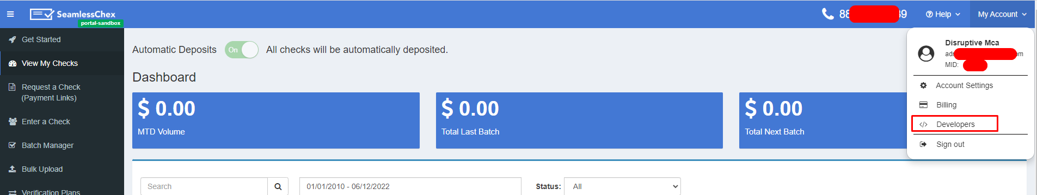

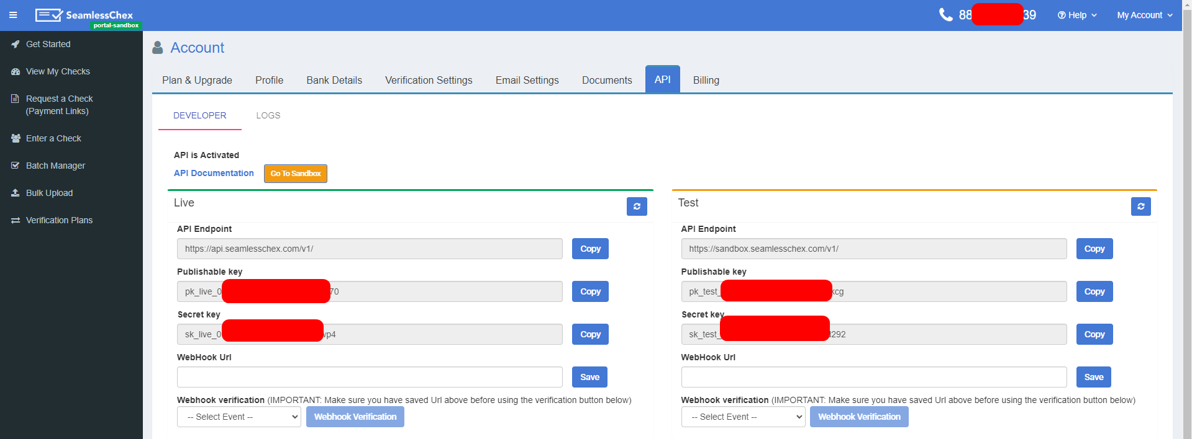

* **CRM** (Customer Relationship Management) Portal
* Hubspot (<https://www.hubspot.com/>)

* APP Key

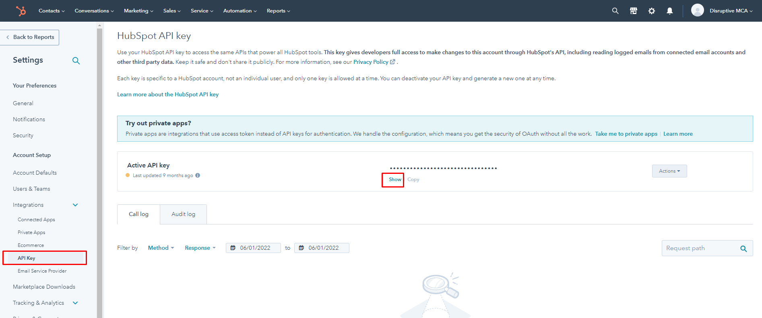

* portal ID and form ID

You need to create contact by hubspot form.

If user visit your website from social sites, hubspot create

So hubspot can analysis route to visit.

In other words, users can get your website link from social sites or other methods.

Hubspot analysis visit methods by route to visit.

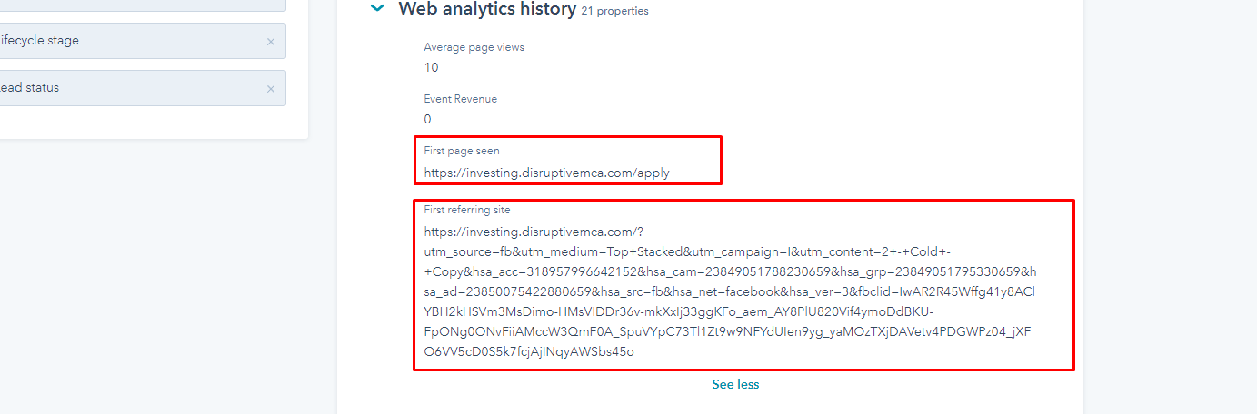

For this, you have to create hubspot form.

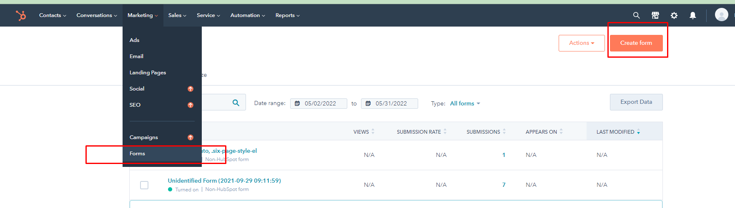

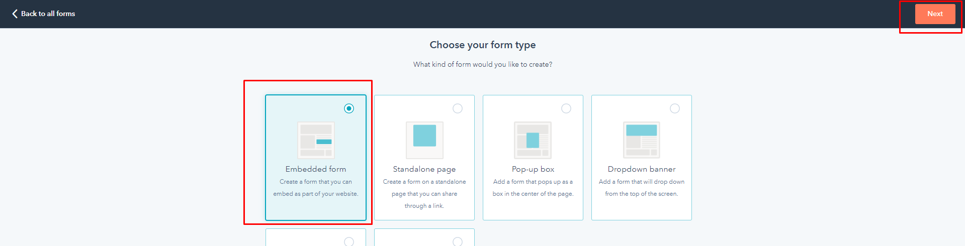

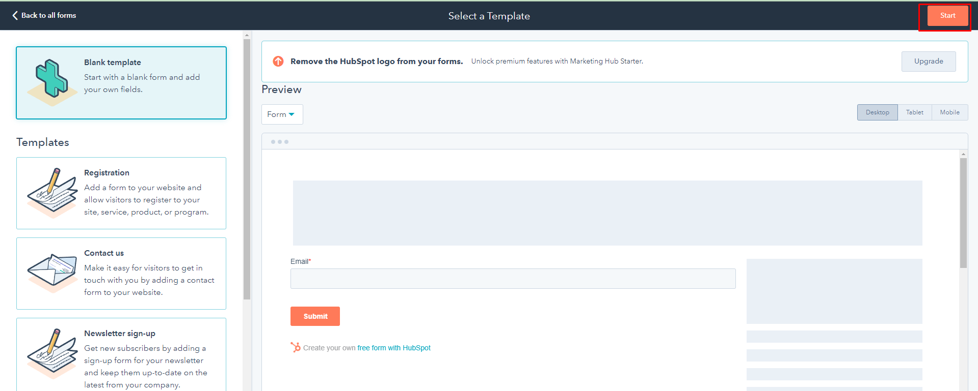

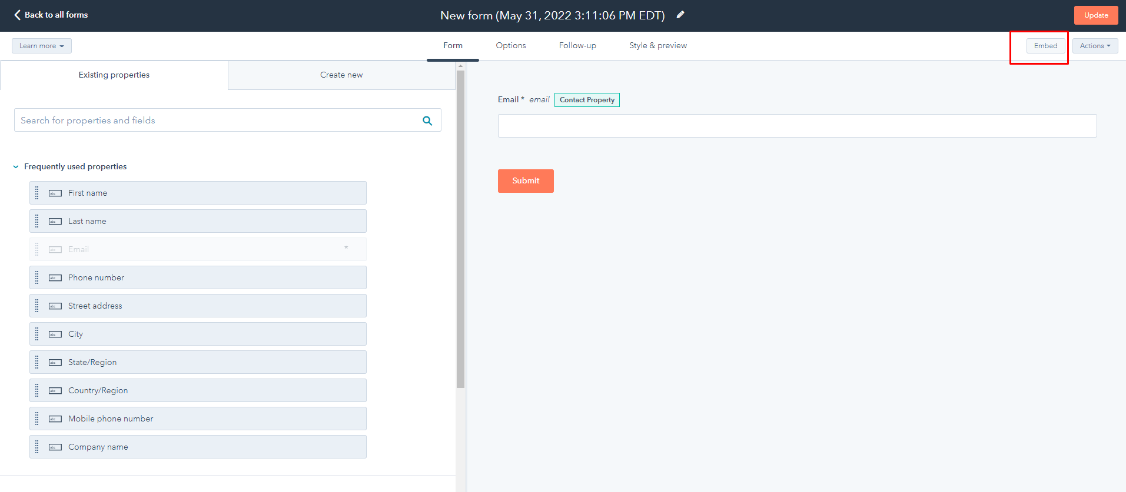

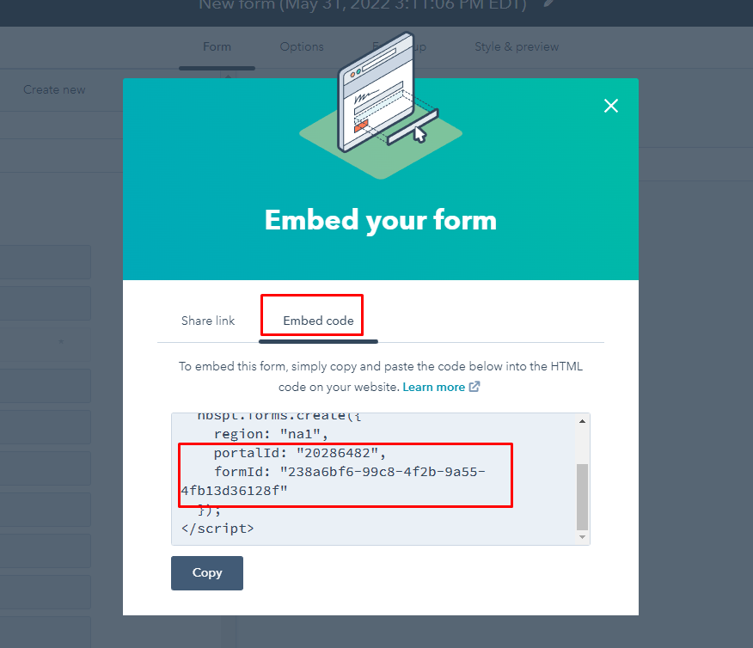

You need to embed this code in the your website.

* get property name and value

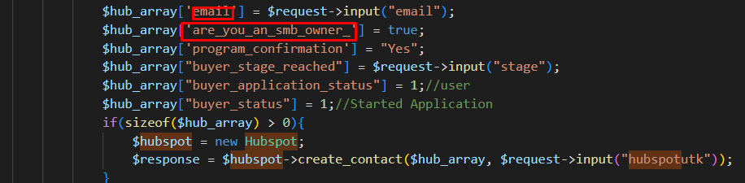

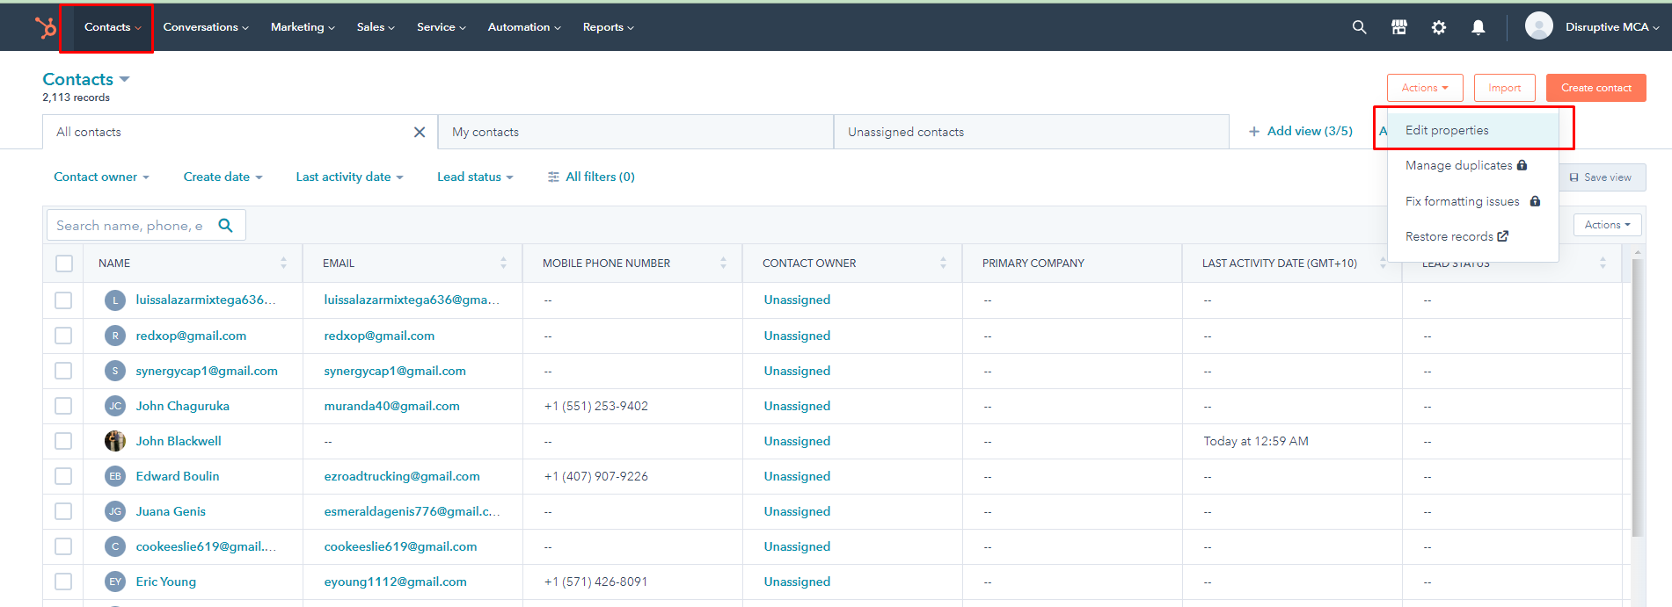

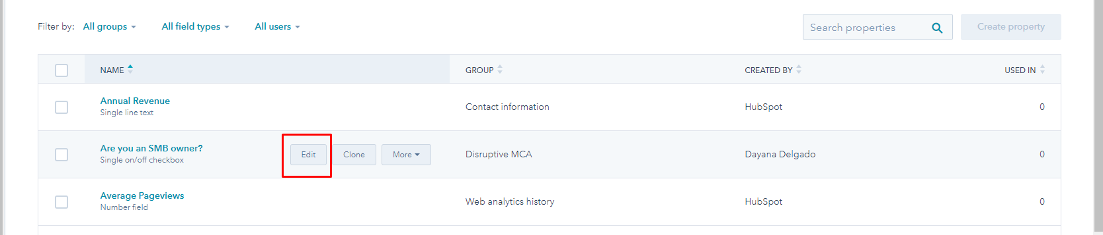

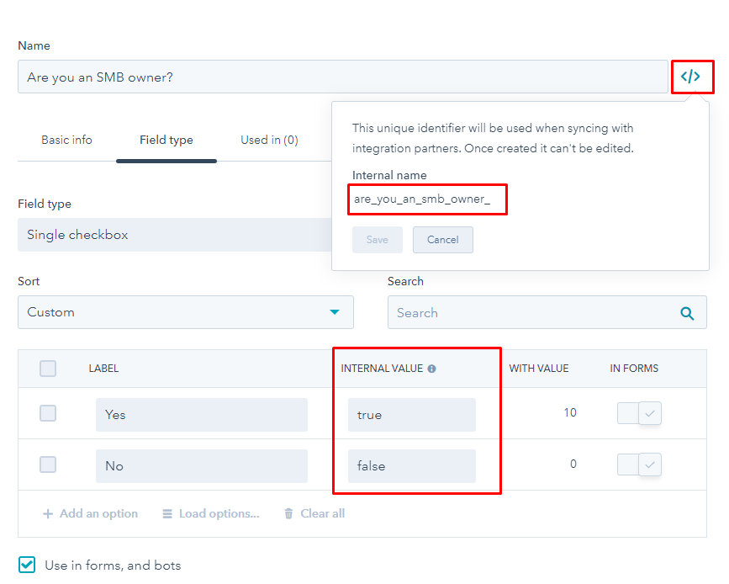

* **Bank Verify**
* Decision Logic (<https://www.decisionlogic.com/>)
* **Google Sheet**
* <https://drivemarketing.ca/en/blog/connecting-laravel-to-a-google-sheet/>

****you can use below google script for find row in the sheet*****

* <https://stackoverflow.com/questions/63496284/google-sheets-api-with-php-find-a-cell-value>

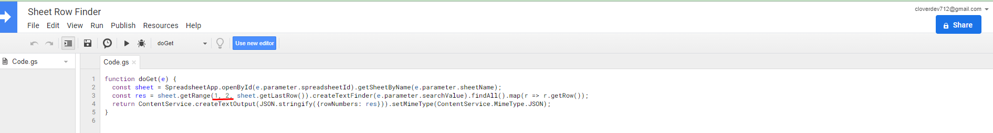

This is column range.

The column for which you are looking for values must be in this range.

* **BTCPay** Server(Bitcoin payment Server - <https://btcpayserver.org/>)

<https://docs.btcpayserver.org/CustomIntegration/>

<https://github.com/btcpayserver/btcpayserver-greenfield-php>

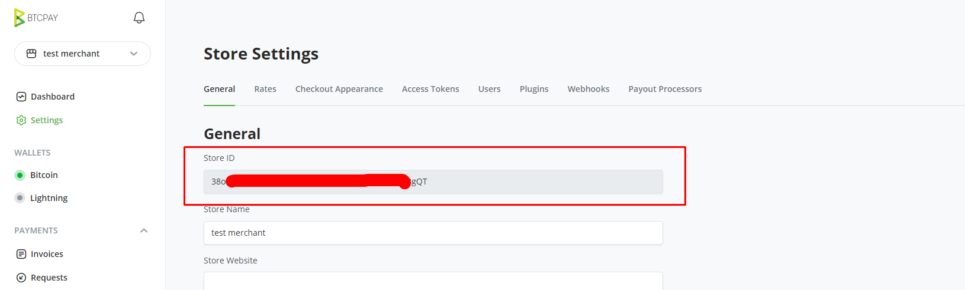

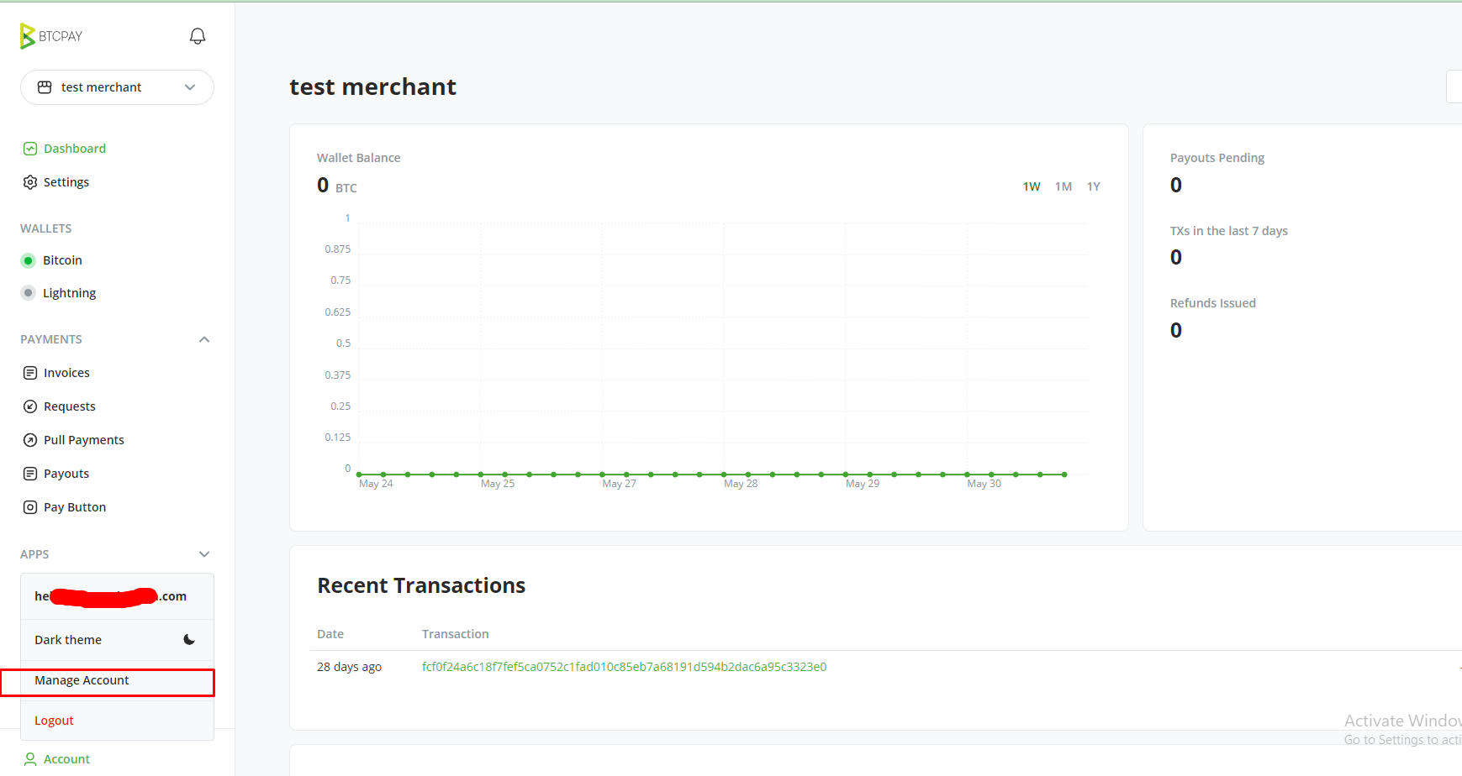

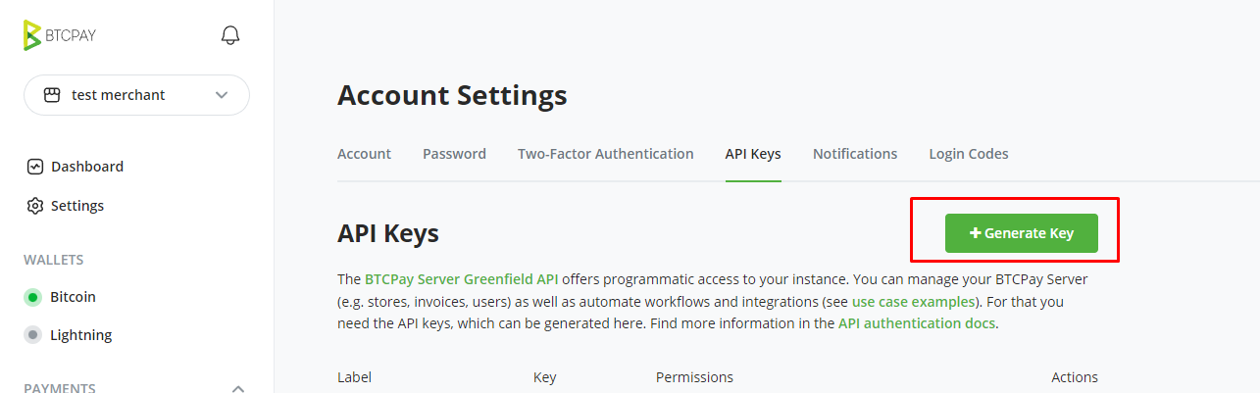

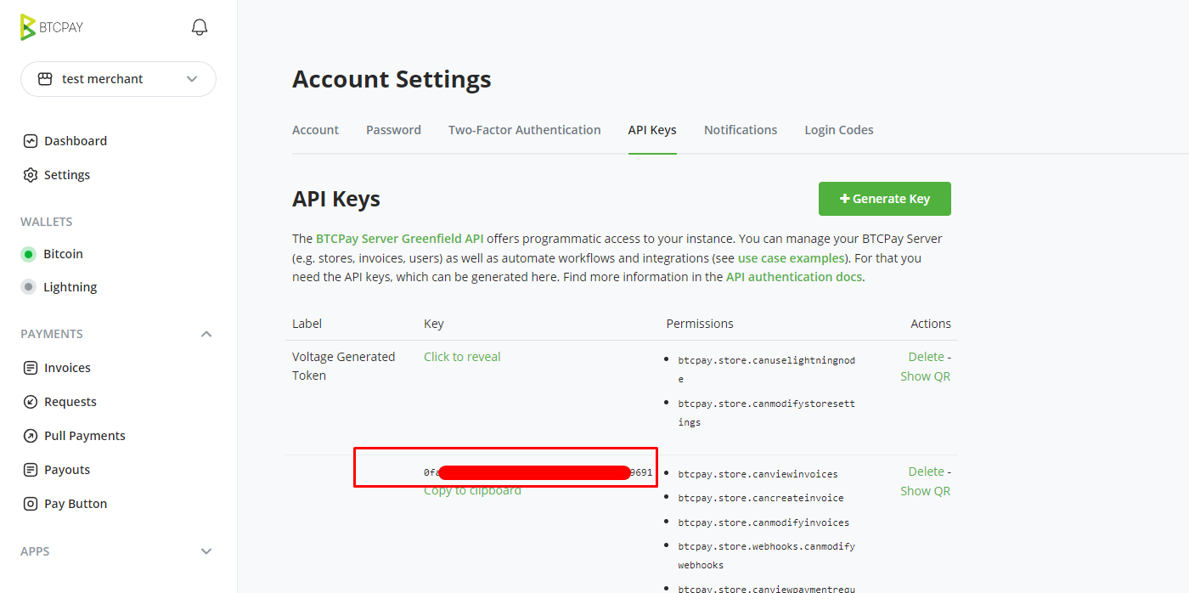

# Laravel packages

----- agent---

<https://github.com/jenssegers/agent>

------recaptcha-----

<https://laravel-recaptcha-docs.biscolab.com/docs/configuration>

----google sheet ----

<https://drivemarketing.ca/en/blog/connecting-laravel-to-a-google-sheet/>

<https://stackoverflow.com/questions/63496284/google-sheets-api-with-php-find-a-cell-value>

----laravel log viewer-----

<https://github.com/melihovv/laravel-log-viewer>

<https://github.com/ARCANEDEV/LogViewer>

----clicksend ------

<https://packagist.org/packages/clicksend/clicksend-php>

----hubspot----

<https://github.com/rossjcooper/laravel-hubspot>

----AWS S3 bucket---

<https://www.itsolutionstuff.com/post/laravel-amazon-s3-file-upload-tutorialexample.html>

Amazon S3:

composer require --with-all-dependencies league/flysystem-aws-s3-v3 "~1.0"

SFTP:

composer require --with-all-dependencies league/flysystem-sftp "~1.0"

CachedAdapter:

composer require league/flysystem-cached-adapter "~1.0"

----authorize.net ----

composer.json

"authorizenet/authorizenet": "2.0.2"

composer update

-------jwt authentication-----

<https://github.com/tymondesigns/jwt-auth>

----create image with background img php--

(certificate)

<https://www.php.net/manual/en/image.examples.merged-watermark.php>

------docusign package-----

<https://github.com/docusign/docusign-esign-php-client>

------image resize------

<http://image.intervention.io/>

------csv import and export----

<https://www.positronx.io/laravel-import-expert-excel-and-csv-file-tutorial-with-example/>

----- firewall-----

<https://github.com/akaunting/laravel-firewall>

----card validation-----

-----bitpay-----------

<https://github.com/vrajroham/laravel-bitpay>

----BTCPay-----

<https://github.com/btcpayserver/btcpayserver-greenfield-php>

------ laravel command line------

composer require laravel/tinker

php artisan tinker

php artisan vendor:publish --provider="Laravel\Tinker\TinkerServiceProvider"

# Reference URL

----------How to make membership site-------

<https://www.matthewwoodward.co.uk/work/ideas/membership-sites/>

------a-simple-two-way-function-to-encrypt-or-decrypt-a-string--------

<https://wppeople.net/blog/a-simple-two-way-function-to-encrypt-or-decrypt-a-string/>

------Authorize.net------

<https://github.com/AuthorizeNet/sample-code-php>

<https://github.com/AuthorizeNet/sample-code-php/blob/master/RecurringBilling/get-subscription.php>

<https://developer.authorize.net/hello_world/testing_guide/>

<https://developer.authorize.net/hello_world/>

-----Authorize.net error codes----

<https://developer.authorize.net/api/reference/features/errorandresponsecodes.html>

------jquery sortable------

<https://jqueryui.com/sortable/#empty-lists>

----mulit step form Bootstrap----

<https://bbbootstrap.com/snippets/multi-step-form-wizard-30467045>

[https://mdbootstrap.com/docs/jquery/components/stepper/#](https://mdbootstrap.com/docs/jquery/components/stepper/)!

<https://johann-s.github.io/bs-stepper/>

---make API in codeigniter----

<https://www.cloudways.com/blog/rest-api-in-codeigniter/>

------implement recaptcha codeigniter----

<https://www.itsolutionstuff.com/post/php-codeigniter-3-google-recaptcha-form-validation-exampleexample.html>

------find bandwidth info------

<https://support.bandwidth.com/hc/en-us/articles/360033658613-Messaging-V2-API-Account-Setup-UI>-

--------get youtube thumbnail url------------

<https://commentpicker.com/youtube-video-id.php>

------- password validation display-----

<https://www.w3schools.com/howto/howto_js_password_validation.asp>

-----------svg maker------------

<https://vectr.com/>

---------payment card form example----

<https://codepen.io/quinlo/pen/YONMEa>

<https://www.digitaldesignjournal.com/credit-card-payment-form-html-css/>

<https://www.cssscript.com/tiny-js-library-create-interactive-payment-form-datpayment/>

-----domain change------

<https://bloggingtek.com/how-to-point-domain-from-godaddy-to-siteground/>

----- protect input copy paste----

<https://sumtips.com/how-to/prevent-copy-cut-paste-text-field/>

-------western union---------

<https://www.wikihow.com/Receive-Money-from-Western-Union>

--------google site verification--------

<https://kinsta.com/blog/google-site-verification/>

--------hubspot---------------

<https://developers.hubspot.com/docs/methods/contacts/create_or_update>

<https://knowledge.hubspot.com/contacts/hubspots-default-contact-properties>

<https://knowledge.hubspot.com/contacts/use-lifecycle-stages>

<https://knowledge.hubspot.com/lists/create-active-or-static-lists>

<https://knowledge.hubspot.com/contacts/property-field-types-in-hubspot>

-----trust site mcafee logo------

<https://support.trustedsite.com/hc/en-us/articles/360007385000-Adding-the-TrustedSite-trustmarks>

(hide logo)

<https://support.trustedsite.com/hc/en-us/articles/204462635-Adding-the-main-code-and-floating-trustmark>

-------Liquid progress indicator-----

<https://www.cssscript.com/liquid-progress-indicator/>

-------codeigniter hooks-------

<https://www.javatpoint.com/codeigniter-hooks>

--------file input plugin-----

<https://plugins.krajee.com/file-input>

---------digital signature---------

<https://codepen.io/dus7/pen/qGQbVP>

<https://www.nicesnippets.com/blog/laravel-signature-pad-tutorial-example>

--------right click protect--------

<https://mycyberuniverse.com/developing/disabling-right-clicking-by-using-javascript.html>

---------- video popup-------

<https://fancyapps.com/fancybox/3/>

------- google sitelinks------

<https://www.reliablesoft.net/sitelinks/#create-sitelinks>

-------social thumbnail image add-----

<https://www.adhesion.co.nz/blog/how-to-change-website-thumbnail-in-facebook-post>

----- image size for website----

<https://mediag.com/blog/popular-screen-resolutions-designing-for-all/>

------- add facebook pixel code -------

<https://www.jonloomer.com/2017/02/24/facebook-pixel/>

--------------rss feed--------------- <https://github.com/hasokeric/codeigniter-rssparser>

----------------change image color-----

<https://codepen.io/noahblon/pen/ZbjmbK/>

---------lazy load plugin-------

<https://github.com/verlok/vanilla-lazyload>

-------- bootstrap notify----

<http://bootstrap-notify.remabledesigns.com/>

---- change remote desktop port----

1:

<https://docs.microsoft.com/en-us/sql/reporting-services/report-server/configure-a-firewall-for-report-server-access?view=sql-server-ver15>

2:

<https://docs.microsoft.com/en-us/windows-server/remote/remote-desktop-services/clients/change-listening-port>

---laravel google sheet package

<https://github.com/kawax/laravel-google-sheets>

<https://drivemarketing.ca/en/blog/connecting-laravel-to-a-google-sheet/>

----sheet row finder--------

<https://stackoverflow.com/questions/63496284/google-sheets-api-with-php-find-a-cell-value>

-----learn english----

<http://nicetalkingwithyou.com/mp3-downloads/mp3-downloads-text1/>

<http://www.effortlessenglish.libsyn.com/>

<https://esl.culips.com/free-samples/>

----connect github to siteground----

<https://www.siteground.com/tutorials/ssh/putty/>

<https://www.siteground.com/tutorials/sg-git/clone-github/>

<https://www.siteground.com/tutorials/ssh/listing/>

-----jwt auth----

<https://hasura.io/blog/best-practices-of-using-jwt-with-graphql/>

-----Authorize.net error code list----

<https://developer.authorize.net/api/reference/features/errorandresponsecodes.html>

----- freelancer ethics----

<http://www.instantshift.com/2013/02/12/business-ethics-in-freelancing-a-primer/>

-----image creat with background image php

<https://www.php.net/manual/en/image.examples.merged-watermark.php>

------- echart -------

<https://echarts.apache.org/en/index.html>

------image compression-----

<https://cloudinary.com/pricing>

------card validation js-----

<https://github.com/jondavidjohn/payform#api>

------seamlesschex(ACH API) -----

<https://developers.seamlesschex.com/seamlesschex/docs/>

---github page build------

<https://dev.to/vaghelabhavesh/customizing-github-profile-page-4jf8>

<https://profilinator.rishav.dev/>

-----Email health checker-----

<https://mxtoolbox.com/emailhealth>

-----Reverse DNS does not match SMTP Banner error---

<https://www.siteground.com/kb/configure-spf-dkim-dmarc-records/>

------software requirements specification-----

<https://relevant.software/blog/software-requirements-specification-srs-document/>

-------simple event calendar--------

<https://github.com/brospars/simple-calendar>

-------Free Coin Price API-----

<https://blockchain.info/api/exchange_rates_api>

# Reference Tool

-----Invoice Generator-----

<https://app.freeinvoicebuilder.com/#build>

-----Hiragana Converter-----

<https://www.lexilogos.com/keyboard/hiragana.htm>

------file transfer tool------

<https://www.myairbridge.com/en/>

----------web font generator------

<https://transfonter.org/>

------ css compress-------

<https://csscompressor.com/>

---------image optimizer---------

<https://www.imagerecycle.com/>

---------3D js library three.js----

<https://threejs.org>

[http://wowslider.com/3d-slider-jquery-fresh-cube-demo.html#](http://wowslider.com/3d-slider-jquery-fresh-cube-demo.html)

<https://www.jqueryscript.net/rotator/jQuery-Plugin-For-360-Degree-3D-Panoramic-View-3dEye-js.html>

<https://www.jqueryscript.net/tags.php?/3D/>

[https://ariona.github.io/hover3d/index.html#](https://ariona.github.io/hover3d/index.html)

<https://cssanimation.rocks/spheres/>

<https://uicookies.com/css-page-transition/>

---------css animation----

<https://www.creativebloq.com/inspiration/css-animation-examples>

-------text animation--------

<https://codepen.io/arlinadesign/pen/BxgRPb>

------shopify analzer--------

<https://analyze.speedboostr.com>

------make short url-----

<https://www.shorturl.at/>

--recieve sms msg by virtual phonenum----

<https://receive-smss.com/>

----favicon generator-----

<https://realfavicongenerator.net/>

----icon generator-----

<https://icons8.com/>

------chartist.js chart plugin-----

<https://gionkunz.github.io/chartist-js/index.html>

-------chatist.js tooltip------

<https://codepen.io/niketmalik/pen/BZjgpQ>

----min compress js. css-----------

<https://www.minifier.org/>

--------base 64 converter----

<https://base64.guru/converter/encode/image/svg>

----------regular expression------------

<https://regexr.com/>

--------images to webp---------

<https://webp-converter.com/>

----------youtube viewer-----

<http://viewpure.com/>

----------location API-----

<https://app.ipgeolocation.io/>

----- phone verify sms----

<https://pingme.tel/>

------mobile test----

<https://appetize.io>

------DNS check tool----

<https://dnschecker.org/#A/driverloanusa.com>

-----Email emulator------

<https://proofjump.com/dark-mode-simulator/>